**Gaming and Simulation Design Principles I**

CIT114

**Game Design Document**

*Chronicles of Paradise*

***Kai Summers, Dillon Wertman, Zachary Progin***

Fall 2017

*Date*

**Design History**

***Updated prior each submission***

* + Version 1.0 – *9/20/2017.* Part 1.
  + Version 2.0 – *10/29/2017.* Part 2. *Further detailed player actions from Part 1. Described the interactions between the player and the game world. Structured the different sections of levels.*
  + Version 3.0 – *11/19/2017*. Part 3. *Detailed controls, inerfaces, and levels. Touched up procedures and rules.*
  + Version Finale – *11/19/2017*.. Part 4. *Fleshed out headings 6 and 7.*

Table of Contents

1 INTRODUCTION 4

1.1 Game Logline 4

1.2 Vision 4

2 FORMAL ELEMENTS 5

2.1.1 Players 5

2.1.1.1 Target Audience 5

2.1.1.2 Player Interactions Patterns 5

2.1.2 Objectives 5

2.1.3 Procedures 5

2.1.4 Rules 6

2.1.5 Resources 6

2.1.6 Boundaries 6

2.1.7 Outcomes 6

3 DRAMATIC ELEMENTS 7

3.1 Game Characters - *Optional* 7

3.1.1 Player Characters (PC) 7

3.1.2 Non-Player Characters (NPC) 7

3.2 Story - *Optional* 7

3.2.1 Synopsis 7

3.2.2 Complete Story 7

4 GAMEPLAY DESCRIPTION 7

4.1.1 Controls 7

4.1.2 Interfaces 8

4.1.3 Levels 11

5 GAME WORLD 12

5.1 Overview 12

5.2 Key Locations 12

5.3 Physical Objects 12

6 MEDIA LIST 13

6.1 Environments 13

6.2 Characters 13

6.3 Music and Sound Effects 14

# INTRODUCTION

## Game Logline

“When time and space are shattered, how will you traverse the distorted dreamscape of reality?”

## Vision

This game will be a puzzle platformer set in 2D. It will feature gameplay that is shape-based, as well as pattern based. The concept of puzzles and platforming are simple, but combined they can have a complex application. The amount of action taken by the player will equal the amount of thinking they do as they strategize about how to defeat each level. The game will feature increasing difficulty. The human brain enjoys logical thinking involving shapes and patterns, which will help engage the player.

The player can interact with many objects in a level: a lever or button to open doors and walls, moveable blocks to open up areas, or the Orb of Paradise to help restore reality to its former state. The player’s actions will involve running and jumping, the hallmarks of platforming. Puzzles will be created by placing interactable objects in inconvenient ways in order to provide additional obstacles to players.

The player’s actions are limited by the overarching manipulations of physics of each section of levels. The player will be limited by these mechanics, and this will challenge their logical and even expressive thinking. One section will explore the duality of light and dark. Another section will feature the ability to control time and its many vectors. The remaining section will feature a deconstruction of gravity. Each level will combine objects and basic gameplay mechanics with the featured manipulation of physics to offer a unique experience for each level and each section. The sections will be independent of each other, so players will not be locked into linear progression.

The section centering around the manipulation of dark and light will showcase darkness concealing areas of the level and interactable objects. Light will let players see areas of the level map and interactable objects. The section where the movement of time can vary will have the player move at a different speed than other objects in the level. Falling platforms or rising platforms might move differently relative to each other. Lastly, the section that focuses on the inversion of gravity might not only have the player float, but also stand on the level's ceiling or walls.

To help the player overcome these challenges, a peculiar device called the Orb of Paradise will be given to them. It will help restore reality, if only for a moment. In the section dealing with light and dark the orb can emit a bright flash of light that slowly fades. In the section where time is malleable as water, the orb can cause the player or objects to speed up or slow down. In the last section which deals with gravity the Orb can cause gravity to be restored to normal, or reverse gravity.

The player’s level of engagement will come from his or her desire to complete a level, and every time they succeed, they will want to continue in the game to experience that feeling again. Their action will be limited by the strategy they use to complete levels, and each level can be solved in different ways. Some levels may have a key needed to open a door to reach the end of a level. The non-linearity of the game through multiple, nonsequential sections of levels will further help to engage the player as the logical process of solving a puzzle can be complemented by creative expression.

Platformers and puzzle games are very popular in the gaming world. Platformers like Super Mario Bros. have defined the platformer genre, and puzzle games like Portal have set a high standard. The first goal of this game is to seamlessly meld these two formats together in a fun and interesting way by challenging the player’s thinking through a multitude of solutions to each puzzle. This will teach strategy to the player through trial and error as they find the best ways to utilize game mechanics and objects to solve each puzzle. The player will be able to take away enhanced spatial visualization, problem solving skills, and cognitive responses from the game.

This game will offer a new, exciting experience to players seeking challenge, strategy, and simple gameplay through complex applications. The player will experience real challenge by only using his or her skills. Arbitrary challenge like random number generation and increased health or damage of enemies will not exist. The puzzles will be vexing, and will entice the player to continue in the face of defeat. The game will leave players with a sense of accomplishment and relief of overcoming levels as well as offer an escape from reality, not through immersive story, but through riveting gameplay.

# FORMAL ELEMENTS

### Players

#### Target Audience

Our target audience is both male and female ages 12 and up residing in English-speaking countries.

#### Player Interactions Patterns

This game is “Single Player versus Game” because the player will be working alone and completing puzzles in order to complete all levels so they can beat the game.

### Objectives

This is a solution-objective game because the player will be solving puzzles and platforming in order to complete the game and nothing else.

### Procedures

1. Use the cursor and left mouse button to select start
2. Walk left and right using the A and W keys respectively
3. Press spacebar to jump
4. Hold Enter to grab moveable objects
5. Move the character into a key to pick it up and equip it
6. Move a character to a locked door (with a key equipped) to open it
7. Press Enter in front of a level exit to proceed to the next level
8. Press the W key to activate the Orb of Paradise

### Rules

Rules:

1. Keys must be equipped to unlock doors.
2. Players cannot move through closed doors, gates, or blocks.
3. Players must complete a level before moving onto the next level.
4. If players make the level uncompletable in anyway, the level will restart.

Rules(Dark/Light):

1. Darkness conceals objects and level areas. Light reveals objects and level areas.
2. Objects and areas in darkness cannot be interacted with.
3. Activating the orb of paradise emits a bright light that can cast away darkness.

The player will learn the rules through a combination of game instructions and trial and error.

### Resources

The only resource that will be managed are the keys collected and used throughout the levels. They will be managed through a key counter as part of the interface; obtaining the keys will add to the counter and using keys will detract from the counter. The player will not directly manage this resource, and it instead will be managed by the game through player actions.

### Boundaries

The physical boundaries include the edges of the play area, walls, and any rooms inside a level that can only be accessed by completing a puzzle. Conceptual boundaries include the level of the player’s critical-thinking and problem-solving skills, and their perseverance.

### Outcomes

If the player completes all of the puzzles in a level, they win that level. If a player completes all of the levels, they win the game.

# DRAMATIC ELEMENTS

## Game Characters - *Optional*

### Player Characters (PC)

Not Applicable

### Non-Player Characters (NPC)

Not Applicable

## Story - *Optional*

### Synopsis

Not Applicable

### Complete Story

Not Applicable

# GAMEPLAY DESCRIPTION

### Controls

|  |  |
| --- | --- |
| **Action** | **Button** |
| Move Left | A |
| Move Right | D |
| Jump | Spacebar |
| Crouch | Control |
| Interact with Objects/Doors | Enter |
| Activate Orb of Paradise | W |
| Restart Level | R |
| Show Help | H |
| Exit | Escape |

### Interfaces

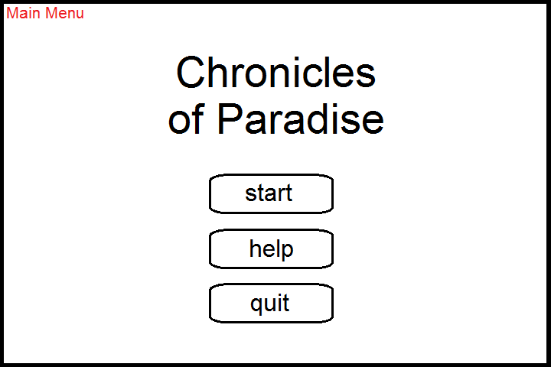

**Main Menu:** The three buttons will be interacted with through the left mouse button. The ‘start’ button will take the player to the Level Select. The ‘help’ button will take the player to the Instructions. The ‘quit’ button, as well as the Escape key, will exit the game.

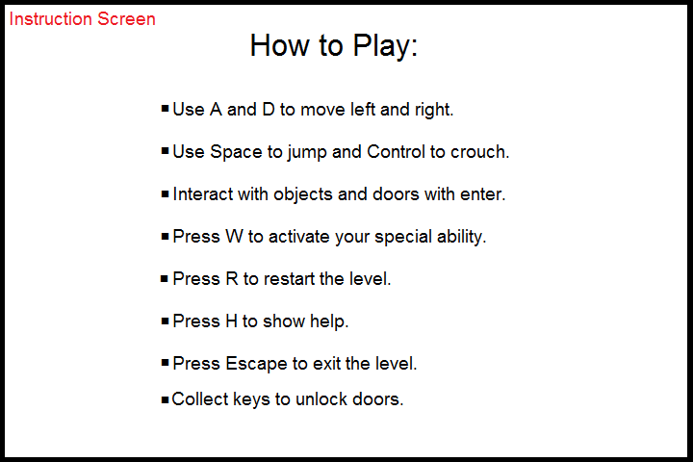

**Instructions:** The screen displays the controls to the game, as well as what to do to complete the levels.

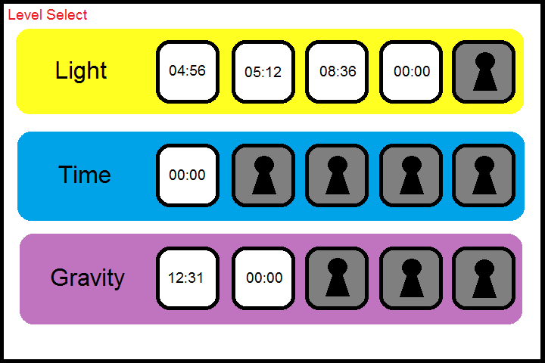

**Level Select:** The Level Select screen can be interacted with through the left mouse button and the Escape key. Clicking a level will immediately start it, and the Escape key will take the player back to the Main Menu. The three sets of levels are shown, with the first level of each unlocked immediately. Once a level is completed, the next level in that set unlocks. If a level is completed, the time taken is shown. If a level has not yet been completed, the time will be shown as “00:00”.

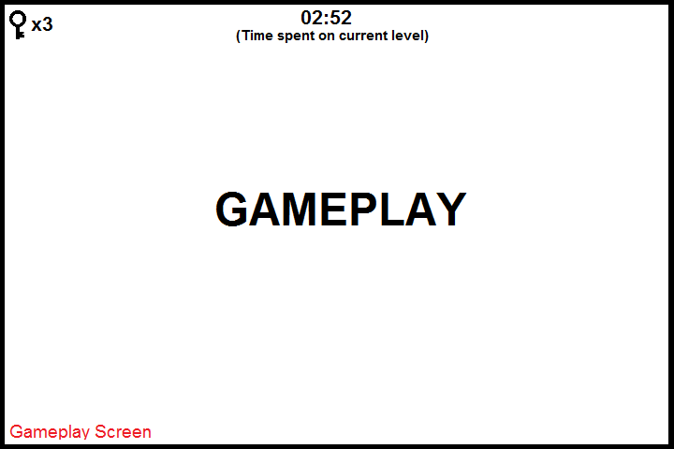

**Gameplay:** The Gameplay Screen can be interacted with through the gameplay controls, as well as the Escape key to return to Level Select, the H key to show instructions, and the R key to restart the level. The current time spent on the level is shown at the top, and the number of collected keys is shown in the top left corner.

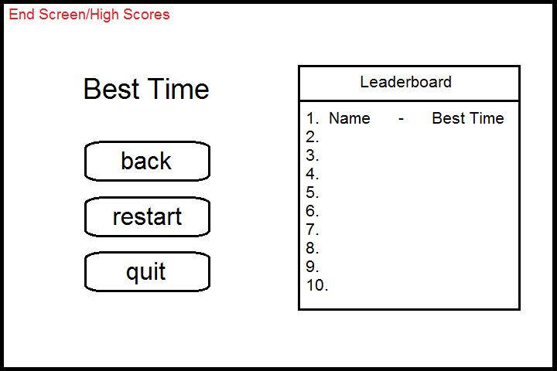

**End Screen:** This screen can be interacted with through the left mouse button and the keyboard. The player will be prompted to enter their name if their score makes the leaderboard. The back button will take the player back to Level Select. The quit button will quit the game. The restart button will ask for player confirmation, and then erase the player’s save and return the player to the Main Menu.

### Levels

The first level starts with the player spawning in a corner of a large room. In the right adjacent corner is the door to the end of the level. In the opposite corner from where the player spawns is the key needed to unlock the door, but it is surrounded by glass. There is a lever on the ceiling that needs to be flipped in order to remove the glass casing around the key. In the last corner is the Orb of Paradise. There is only solid floor in the corners and the rest is a gigantic pit. The player must first jump across platforms to get the Orb of Paradise. The player then uses the orb to reveal platforms that lead up to the switch that were previously unseen. The player must climb these platforms to flip the switch before the orb’s powers fade. Then the player goes and retrieves the key and platforms to the door at the end of the level. If the player falls into the pit at any time, they must restart the level.

# GAME WORLD

## Overview

The game world is whimsical and fantasy based. Lush jungles and towering crags make up the landscape. The sky is constantly star-filled with great sprays of nebulae. Lighting is soft and bright. Mixed in with the whimsical landscape are mechanical workings, like steel doors crates of supplies and keys for the doors.

## Key Locations

After you enter the game or complete a level, you will enter a hub where you can pick levels or change settings. Since every level is different there are no key locations within the levels. The levels themselves could be considered key locations since you have to play them to progress through the game.

## Physical Objects

**Orb of Paradise** - The orb will be an object used by the player to activate the level-specific ability. Upon pressing W, it will allow the player to control light, time, or gravity.

**Keys** - Keys will be within the levels in difficult-to-reach places. The player will pick them up upon contact and a key will be added to their key counter. They will be used by the player to unlock doors.

**Doors** - There will be doors within the levels and can be opened by pressing Enter once the player has the key. Some doors will represent the exit of the level and will allow the player to progress to the next level.

**Crates** - Crates will be used in puzzles throughout the levels. They can be picked up by the player via the Enter key, and can also be pushed. The player can use them to reach high places and to depress buttons.

**Levers** - There will be levers which the player can interact with via Enter. They will do things such as opening gates allowing the player into new areas in the level.

**Buttons** - Buttons can be stood on to activate them. They can do things such as opening gates and crates can be placed on them.

# MEDIA LIST

## Environments

Main Backgrounds:

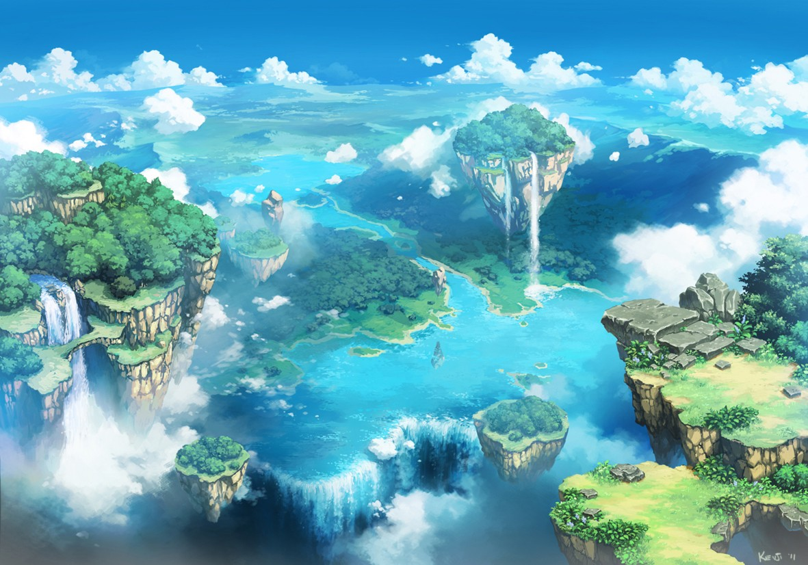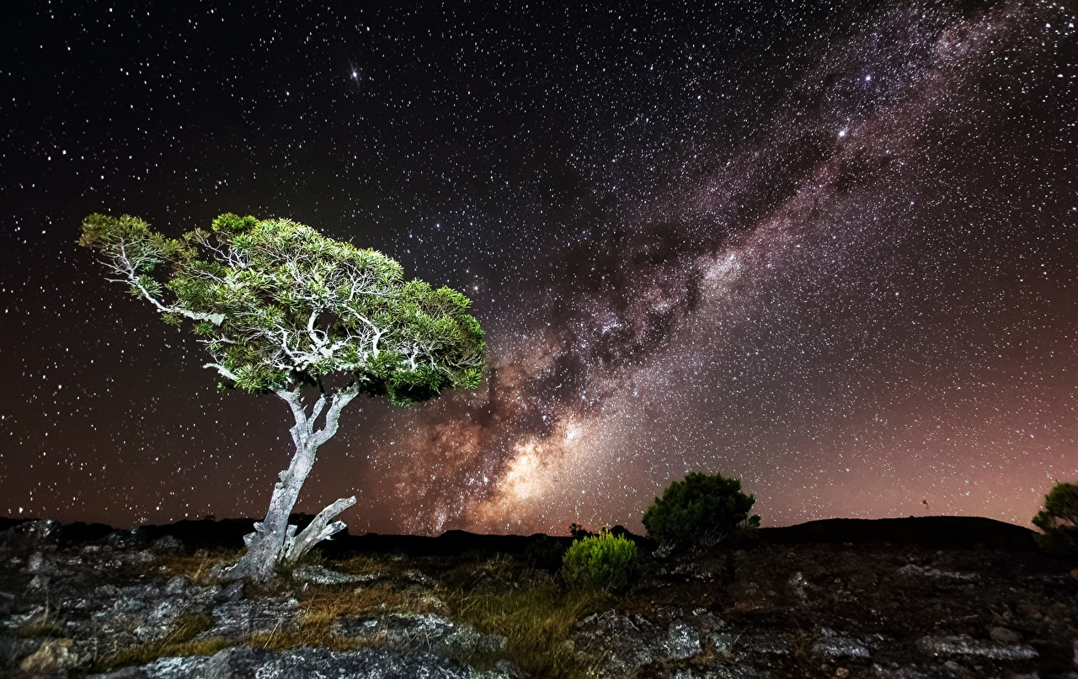

Mechanical Elements:

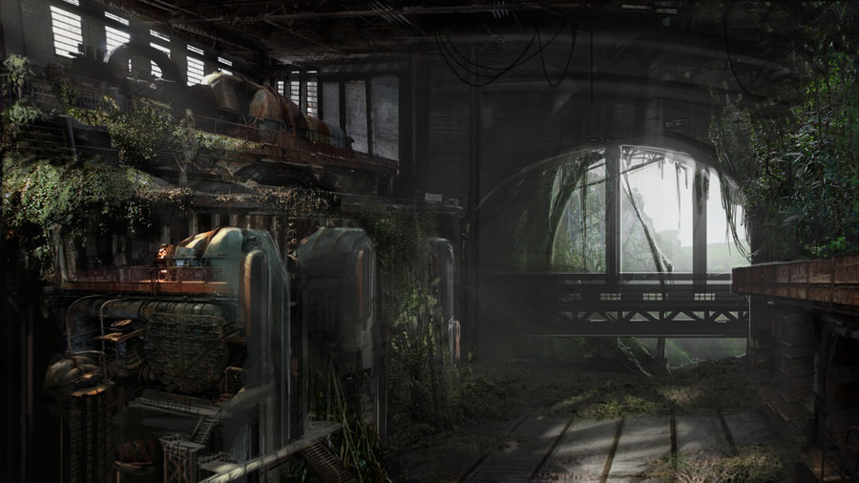

## Characters

Main Character:

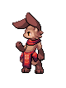

## Music and Sound Effects

Background Music:

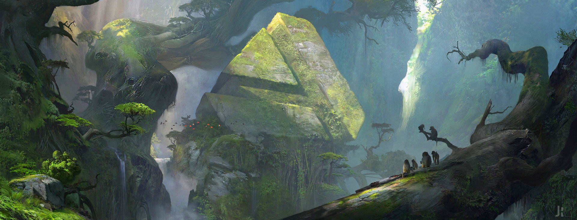

Sound Effects: